**DAILY ONLINE ACTIVITIES SUMMARY**

|  |  |  |  |  |  |  |  |  |
| --- | --- | --- | --- | --- | --- | --- | --- | --- |
| **Date:** | **08/08/2020** | | | | | **Name:** | **Spoorthy Balaji** | |
| **Sem & Sec** | **6th & B** | | | | | **USN:** | **4al17cs098** | |
| **Online Test Summary** | | | | | | | | |
| **Subject** | | **-** | | | | | | |
| **Max. Marks** | | **-** | | **Score** | | | **-** | |
| **Certification Course Summary** | | | | | | | | |
| **Course** | **Salesforce Trailhead** | | | | | | | |
| **Certificate Provider** | | | **-** | | **Duration** | | | **-** |
| **Coding Challenges** | | | | | | | | |
| **Problem Statement: Python program to convert float decimal to Octal number** | | | | | | | | |
| **Status: Solved** | | | | | | | | |
| **Uploaded the report in Github** | | | | | **yes** | | | |
| **If yes Repository name** | | | | | <https://github.com/spoorthybalaji/Daily_Status> | | | |
| **Uploaded the report in slack** | | | | | **yes** | | | |

**ONLINE COURSE**

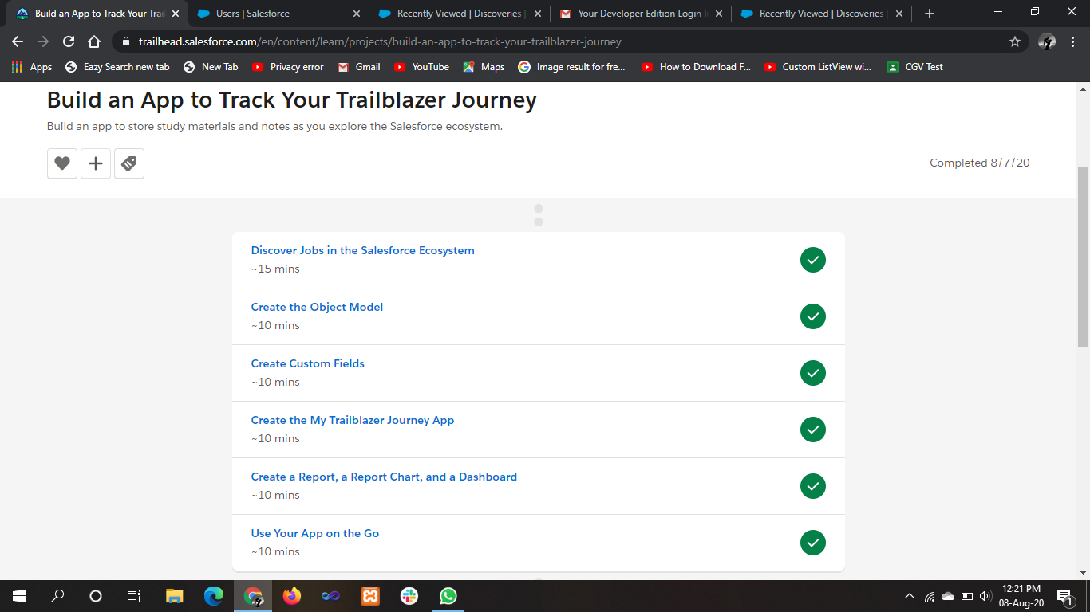

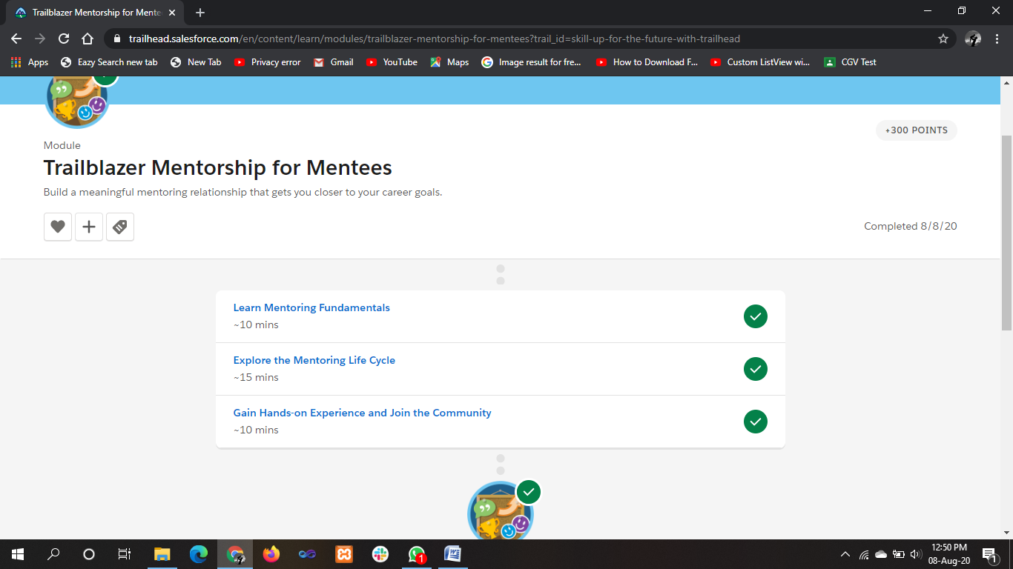

**ONLINE** **CODING**

**Python program to convert float decimal to Octal number**

def float_octal(number, places = 3):

whole, dec = str(number).split(".")

whole = int(whole)

dec = int (dec)

res = oct(whole).lstrip("0o") + "."

for x in range(places):

whole, dec = str((decimal_converter(dec)) * 8).split(".")

dec = int(dec)

res += whole

return res

def decimal_converter(num):

while num > 1:

num /= 10

return num

n = input("Enter your floating point value : \n")

p = int(input("Enter the number of decimal places of the result : \n"))

print(float_octal(n, places = p))

